**Week 4 Solutions**

Spring REST using Spring Boot 3

1. spring-rest-handson :-

**Hello World RESTful Web Service**

The code and the folder structure is attached in the **2.spring-rest handson/spring-learn**  folder

**Output :-**

**Chrome – http/localhost:8080/hello**

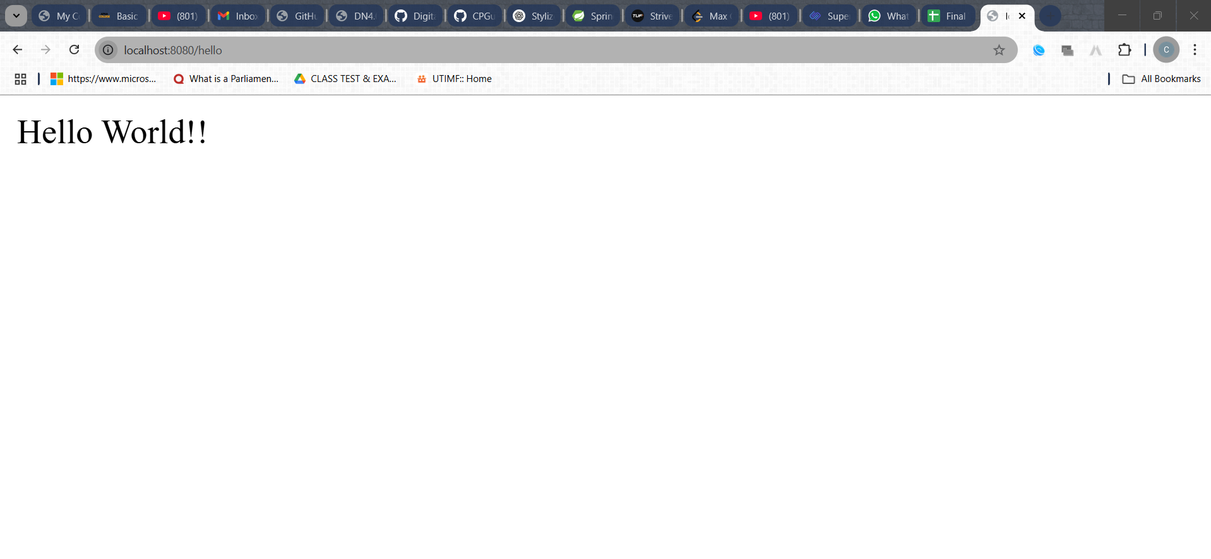

**The hands on file and folder is attached along with it**